Template for Articles
Author A¹, Author B¹, Author C¹, Author D², and Author E³
¹Department of Electronic, XYZ University of Engineering and Technology, Karachi, Pakistan
²Department of Architecture, ABC University of Engineering and Technology, Jamshoro, Pakistan
³Department of Environmental Design, MNO University, Islamabad, Pakistan

Correspondence Author: Author A (authora@gmail.com)

Received February xx, 202x; Revised March xx, 202x; Accepted May xx, 202x

Abstract
These instructions give you guidelines for preparing papers for Journal of Computing and Artificial Intelligence. Use this document as a template if you are using Microsoft Word. Otherwise, use this document as an instruction set. The electronic file of your paper will be formatted further at JCAI. Define all symbols used in the abstract. Do not cite references in the abstract. Do not delete the blank line immediately above the abstract; it sets the footnote at the bottom of this column.

Index Terms: Template, Research Journal, Microsoft Word, Electronic File, Instruction Set.

INTRODUCTION
This template is modified MS Word Document; it provides authors with most of the formatting specifications needed for preparing electronic versions of their papers [1]. All standard paper components have been specified for three reasons: (1) ease of use when formatting individual papers, (2) automatic compliance to electronic requirements that facilitate the concurrent or later production of electronic products, and (3) conformity of style throughout a paper [2]. Margins, column widths, line spacing, and type styles are built-in; examples of the type styles are provided throughout this document and are identified in italic type, within parentheses, following the example.

The study focuses on the following main objectives:

- To develop a theoretical framework.
- To study selected attributes of the topic.
- To find out the effective impact/s, of specific attributes, on the user comfort.

Following are the research questions of the study:

- What are the design considerations regarding need-based facilities?
- Which sub-attributes of the selected user facility in the case study are synchronized with the standards?
- How the comfort level in the case study is affected due to the availability of selected attributes?

Rationale
Some of the attributes are defining and are unavoidable, while some are allied in nature and enhance the basic facilities [3].

Problem Statement
The existing spatial design of premises in Karachi was organized with a limited number of attributes for customers.

LITERATURE REVIEW
The economic, geographical, and political conditions of any country have a direct effect on its population. Economics is in fact concerned with human needs, such as comfort, ease, and luxuries [4].
Henceforth, the following theoretical framework is established through this research.

THEORETICAL FRAMEWORK
The literature review has signified some of the attributes of the premises specifically relevant to the need-based facilities [5]. It is also revealed from the literature review that the attributes of the said premises should consider the contextual approach while developing the architectural design for this activity [6].
These attributes are summed up in the theoretical framework as shown in Table I.

Table 1: Theoretical Framework of Attributes [7]
Most Frequent User | Selected Attributes | Sub- Attributes
Customers, Shopkeepers | Need-Based Facilities | Wash Room
Customers, Shopkeepers | Need-Based Facilities | Prayer Area
Customers, Shopkeepers | Need-Based Facilities | Automated Teller Machine
Customers, Shopkeepers | Need-Based Facilities | Currency Exchange
Customers, Shopkeepers | Need-Based Facilities | Lost and Found
Customers, Shopkeepers | Need-Based Facilities | Rest Room
Customers, Shopkeepers | Need-Based Facilities | Child Care Area
Customers, Shopkeepers | Need-Based Facilities | Baby Cart
Customers, Shopkeepers | Need-Based Facilities | First Aid Room
Customers, Shopkeepers | Need-Based Facilities | Bank
These attributes are selected for the conduct of further research by the quantitative method are need-based facilities.

METHODOLOGY
The research adopts a quantitative methodology for collecting data through a selected case study. The case study was selected in the city of Karachi. The secondary sources included literature reviews, which consisted of documents, i.e., publications, earlier research, reports, census, archives, books, personal records, and referential material available in relevance to the area of study [8]. The primary sources included questionnaires separately structured for customers and shopkeepers and observations (through site visits, photographs, and architectural drawings for reference). Following this, a checklist was developed in accordance with selected attributes, which is the combination of the standards as prescribed by different relevant sources available in the literature and observations.

$H\left(x,σ\right)= \left[\begin{matrix}L_{xx}\left(x,σ\right) & L_{xy}\left(x,σ\right) \\ L_{xy}\left(x,σ\right) & L_{yy}\left(x,σ\right)\end{matrix}\right]$ (1)

Where;
$L_{xx}\left(x,σ\right)$, convolution of Gaussian second-order derivative $\frac{∂^{2}}{{∂x}^{2}}g(σ)$, and similarly for $L_{xy}\left(x,σ\right)$ and $L_{yy}\left(x,σ\right)$.
Both data collection sources were processed through the developed checklist of selected attributes. The responses from the questionnaires were collected and statistically processed for the findings. These findings were further analyzed to draw conclusions [9].

Justification for Selection of Case Study
The premises are located in Clifton Block-5, Karachi. By responding to the expanding demands of both local corporate firms and multinationals, the Clifton area is swiftly converting into a facilitator for economic growth, development, and diversification [10].

Population
The population of the study is mainly users of the premises. These users are sub-divided into two categories, i.e., customers and shopkeepers. The management staff is not included in the research as their movement and usage are very limited [12].


Figure 1: Flow Diagram of Research Design
It then follows the process of selecting a sample from the user population while the research is conducted through a quantitative approach/method as shown in Figure 1.

Data Collection
Two types of data are collected for this research; primary and secondary. The primary data sources are the questionnaires and observations (site visits, photographs, and architectural drawings) made on-site during the case study. The secondary data caters to the literature resources of multiple types, like books, articles, websites, newspapers, and more [13].

- Location:
The premises are situated in Clifton Block-5, Karachi on a 200-foot wide double road, Khayaban-e-Iqbal. Figure 2 marks the location of the premises.


Figure 2: Location of the Premises [14]

- Overview of the Premises:
Emerald Mall is constructed at Do Talwar, Clifton, Karachi with a unique and innovative concept. The location of the Mall is near the business hub of the city.


Figure 3: The Facility is on Ground Plus Three Floors [15]

The overview of the chosen facility is given below:

- Name:
- Design of Facility:
- Location: Khayaban-e-Iqbal, Clifton, Karachi.
- Year of Completion: 2010, December.
- Area of the Plot: 140’-0’’x 230’-0’’=32,200 Square feet (Sqft), 32,200/9=3,577 Square yards (Sqyd), 3,577/4840= 0.7392 Acre.
- Building Type: Retail and Corporate Offices.

ANALYSIS/FINDINGS AND DISCUSSION

Analysis

- Location of Washroom:
In response to the location of the washroom, 100% of the respondents mentioned that washrooms should be on every floor, while no respondent stated that they should be on just one floor as shown in Figure 4.

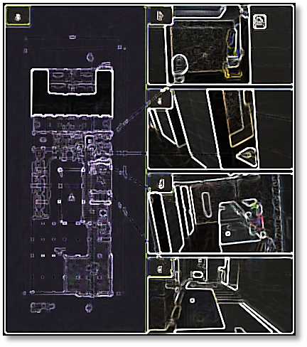
Figure 4: Layout of Washrooms

This is mentioned in Section II: literature review; stated in standards [16-19], and referred by scholar [20].

- Suggestion in Prayer Area:
The prayer area was there but not with adequate space, and the ablution area was missing as shown in Figure 5.

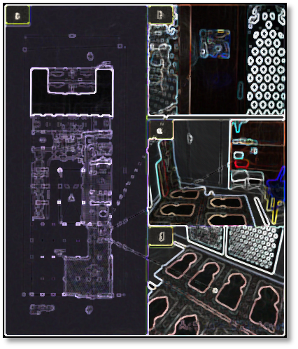
Figure 5: Layout of Prayer Area

CONCLUSION
The research concluded that an analysis conducted after the research study had assisted in meeting the aims of the research. The findings of the research that was based on different questions concluded that premises have some need-based facilities that were improper in many respects, while some of the necessary facilities were suggested to be provided. The findings of the research also demonstrate the inclusive nature of the attributes of the said premises in the case study.

RECOMMENDATIONS/ SUGGESTIONS
The research culminates in several different ways that suggest some of the key points regarding need-based facilities that need to be addressed in order to enhance the user facilities. As it is a basic need, it is recommended that the washrooms be on every floor rather than having users move up and down in search of washrooms, and they must accommodate differently-abled people on every floor. The prayer area should have sufficient space that caters to the ablution area too. This is because it will make it easy for people to perform ablution for prayer and pray at the same place. Moreover, some people prefer using chairs for prayer; a sufficient space will enable them to do so.
Acknowledgment
The authors would like to thank almighty Allah first and then the management of XYZ University of Engineering and Technology, Karachi, Pakistan, for their support and their assistance throughout this study.
Authors Contributions
The contribution of the authors was as follows: Author A’s contribution to this study was the concept, technical implementation, and correspondence. The methodology to conduct this research work was proposed by Author B. Data collection and supervision were performed by Author C. Author D facilitated the data compilation and validation. Author E’s contribution was project administration, and paper writing.
Conflict of Interest
The authors declare no conflict of interest and confirm that this work is original and not plagiarized from any other source, i.e., electronic or print media. The information obtained from all of the sources is properly recognized and cited below.
Data Availability Statement
The testing data is available in this paper.
Funding
This research received no external funding.
References
- Wagner, T., & Rudolph, T. (2010). Towards a hierarchical theory of shopping motivation. Journal of Retailing and Consumer Services, 17(5), 415- 429.
- Bakırtaş, H., & Divanoğlu, S. U. (2013). The effect of hedonic shopping motivation on consumer satisfaction and consumer loyalty. International Journal of Asian Social Science, 3(7), 1522-1534.
- Ribeiro Cardoso, P., &Carvalho Pinto, S. (2010). Hedonic and utilitarian shopping motivations among Portuguese young adult consumers. International Journal of Retail & Distribution Management, 38(7), 538-558.
- IDECK, (2010). Urban Entertainment Centers in Major Cities of Karnataka, a Draft Feasibility Study. Infrastructure Development Corporation (Karnataka) Limited.
- Britannica, E. (1993). Encyclopædiabritannica. Chicago: University of Chicago.
- Ismail El-Adly, M. (2007). Shopping malls attractiveness: a segmentation approach. International Journal of Retail & Distribution Management, 35(11), 936-950.
- Han, H., Sahito, N., Thi Nguyen, T. V., Hwang, J., & Asif, M. (2019). Exploring the Features of Sustainable Urban Form and the Factors that Provoke Shoppers towards Shopping Malls. Sustainability, 11(17), 4798.
- Karachi Population. (2021). Retrieved from https://worldpopulationreview.com/world-cities/karachi-population
- Kemp, S. (1998). Perceiving luxury and necessity. Journal of Economic Psychology, 19(5),591-606.
- Hammar, T. (1990). Democracy and the nation state: Aliens, denizens, and citizens in a world of international migration. Gower Publishing Company.
- Lim, J., & Beatty, S. E. (2011). Factors affecting couples' decisions to jointly shop. Journal of Business Research, 64(7), 774-781.
- Jackson, V., Stoel, L., & Brantley, A. (2011). Mall attributes and shopping value: Differences by gender and generational cohort. Journal of retailing and consumer services, 18(1), 1-9.
- Alkibay, S., Tuncer, D., & Hosgor, S. (2007). Shopping Centers and Management. Adana, Turkey: Siyasal Bookstore.
- Anderson, R. E. (1973). Consumer dissatisfaction: The effect of disconfirmed expectancy on perceived product performance. Journal of marketing research, 10(1), 38-44.
- Parasuraman, A., Zeithaml, V. A., & Berry, L. L. (1985). A conceptual model of service quality and its implications for future research. Journal of marketing, 49(4), 41-50.
- Oliver, R. L., &Winer, R. S. (1987). A framework for the formation and structure of consumer expectations: Review and propositions. Journal of economic psychology, 8(4), 469-499.
- Parasuraman, A., Berry, L. L., & Zeithaml, V. A. (1991). Understanding customer expectations of service. Sloan management review, 32(3), 39- 48.
- Boulding, W., Kalra, A., Staelin, R., & Zeithaml, V. A. (1993). A dynamic process model of service quality: from expectations to behavioral intentions. Journal of marketing research, 30(1), 7-27.
- Sheth, J. N., & Mittal, B. (1996). A framework for managing customer expectations. Journal of Market-Focused Management, 1(2), 137-158.
- Mitra, D., &Golder, P. N. (2006). How does objective quality affect perceived quality? Short- term effects, long-term effects, and asymmetries. Marketing Science, 25(3), 230-247.

Note: References are in APA Style of Citation.

